**Destination elevator interfaces**

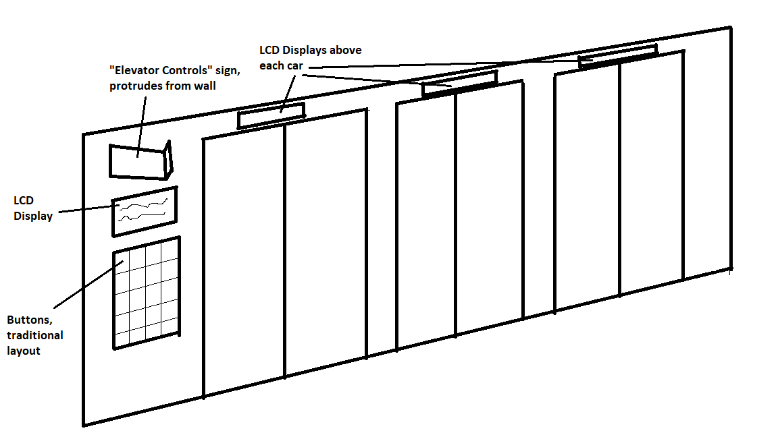

**Figure 1:** Overview of outside interfaces

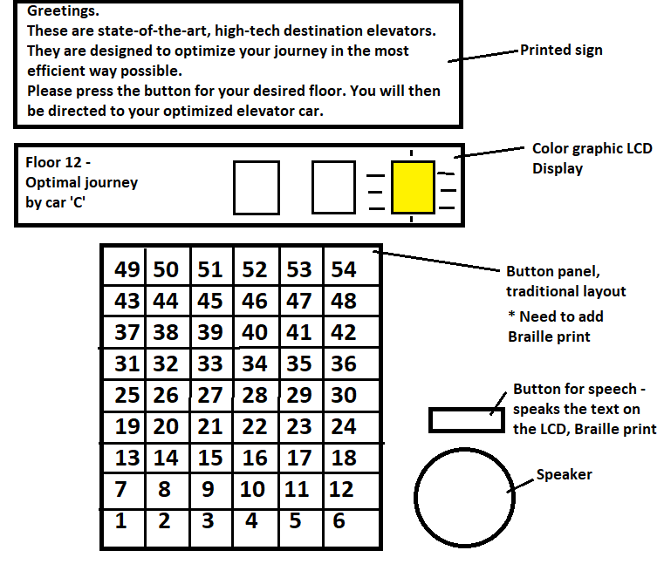

**Figure 2:** Outside interface

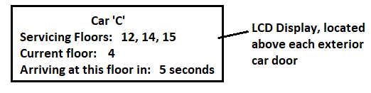

**Figure 3:** Individual car outside interface

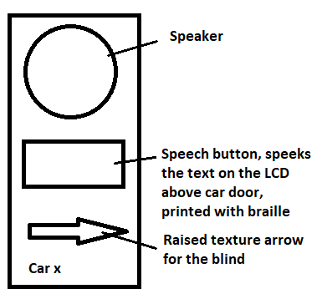

**Figure 4:** Panel next to car door

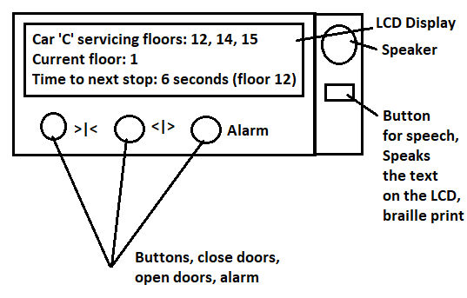

**Figure 5:** Inside car interface

**Conceptual Model:**

There is a large sign that protrudes from the wall at angles so anyone approaching the elevators from the side can easily see that these are the elevator controls.

There is a sign that explains that these elevators are different than traditional elevators. The language used is meant to entice the user by defining it as high-tech and re-iterating that it is designed for optimization and efficiency.

There is an LCD display that shows the floor the user has selected and states in clear language which car to use and uses a graphical mini-map that highlights the correct car to help the user quickly locate their car. A speech button has been added to speak the text that is on the LCD for the blind.

The buttons are using the traditional layout that most people are already familiar with for an elevator to facilitate faster adaptation to the new system. Making the buttons look like elevator buttons will help people understand that these are the elevator controls and they will quickly know how to use them rather than trying to learn a new input method. Braille print will be added to all buttons and signs.

There is an LCD display above each individual car door stating specifically which floors that car is scheduled to travel to, which floor the elevator is currently at, and the amount of time in seconds for the car to arrive at the current floor. This will reinforce the promised high-tech nature by providing relevant information to the user. A speaker and speech button have been added to the side of each car to allow use by the blind. The sign has a raised arrow pointing to the car and the speech button speaks the text that is on the LCD above the car door.

Inside the car is another LCD that clearly displays the floors that the car will travel to and the time to arrive at the next stop and what that stop will be. By providing this much relevant information, the user should have all of their most common questions and concerns answered.

The only buttons available inside the cars are the “Close doors”, “Open doors”, and “Alarm”. These should be the only buttons the user will require.

**Affordances:**

The buttons on the interfaces both inside and outside the elevator are traditional push-buttons. They are meant to be familiar and indicate to users that they control the elevators from outside, not inside. The added speakers afford text-to-speech to allow use by the blind.

**Signifiers:**

The large, angled sign above the elevator controls clearly identifies the elevator controls and the angle makes it visible for anybody approaching from the side. This is assuming the only approaches available are from the side, if the approach to the elevators is from the front, the sign will be placed flat against the wall. The sign must have large print and be of a different color than any other locally placed signage. Braille print has been added to all signs and buttons.

The sign above the LCD display explains that this elevator is different than traditional elevators. It explains why, entices the user with the promise of a faster journey, and provides information on how to use the new system.

The LCD above the elevator buttons displays relevant information about the user’s journey and uses a color indicator on a map to direct them to the correct car.

The LCD’s above the elevator car doors display relevant information about that car, the floors it will travel to, where it is currently located, and the expected time to arrive at the current floor.

A panel has been added next to each car door with a text-to-speech button with braille print and a raised arrow indicating the car.

The LCD inside the car displays relevant information about the car as well. It shows the floors it is travelling to and the expected time to the next stop and what the next stop is. The added speaker and text-to-speech button with braille print will read the information that is on the LCD.

There are pictorial representations for the door controls that are fairly common and should be easily understood by the majority. The alarm button signifier is spelled out because a graphic could be misunderstood. The images will be raised to be readable by the blind and braille print will be added to the Alarm print.

**Feedback:**

The buttons will have a tactile and audible click when pressed, the same as traditional elevators. They will light up after being pressed as well.

The LCD’s provide information in clear language to let the user know that the controls have been pressed, the press has been recorded, and the algorithm has optimized their journey. The mini-map on the display lights up with the correct car to direct the user. The LCD’s above the exterior doors indicate which floors that car is scheduled to travel to. The inside LCD’s state which floors the car is set to travel to and the travel time. The speakers will speak the text on the LCD’s for the blind.

**Natural mapping:**

The buttons for the floors, door controls, and alarm are the same as traditional elevators. This keeps those aspects that are already familiar to users. The controls are located to the side of all cars with no buttons near each car so that users will logically assume that the controls are for the elevators even if they don’t see the large sign indicating that they are the elevator controls. The displays that have information for each individual car are above the doors for that car. This places them in proximity to the car as a natural mapping and also because traditional elevators have indicators above car doors that users are already accustomed to look for. The signs and text-to-speech buttons for each car are next to each car with raised arrows indicating the car they belong to.

**Constraints:**

**Physical:**

The users can only press floor buttons outside the elevators. It is possible and likely that some new users will enter the elevator without selecting a floor assuming that they will be able to do so once inside. Placing more signs could reduce this scenario but if there are too many signs, then it may reduce the likelihood that people will read any signs.

**Logical:**

Users cannot select a floor inside the elevator. Users can only control the doors and raise an alarm inside the elevator. Users that step into the elevator expecting to be able to select a floor will either have to step out and select their floor properly, or wait until they arrive at the first stop, step out, and follow the proper procedure.

**Visibility:**

There is a large angled sign stating: “Elevator controls” above the elevator controls on the outside of the elevator. There are LCD displays at the elevator controls providing information on the elevator controls and above the exterior doors of each car. The elevator controls LCD uses a color display and a mini-map to direct users to the correct car.

The signage is intentionally kept to a minimum to increase the likelihood of being recognized. If too many signs are placed providing more information, it could reduce the likelihood anybody will ready any of them. The text-to-speech buttons and print are located next to the controls and doors in locations where blind people should logically search for them. The braille print will make them easily readable to determine their purpose.